Bioinformatics Lecture 6

You can use the Needleman Wunsch with more than one dimension to compare for example 20 sequences to each other, although in practise this is infeasible because it takes too much memory and computation time.

You want to be able to compare different similar species or similar gene sequences in one go, so this is why we need a different method other than dynamic programming..

Definition of homology

If you have a pair of homologous genes, then they are derived from a common ancestor.
Speciation made the gene split into different genes and they were modified over time.
A good indicator of homology is similar sequences and similar functions of the gene.
It is impossible to prove homology because the common ancestor will be long gone.
So we can only reasonably infer homology.

Homology is about describing similar features, such as eyes. We can infer a homology based on structure and functionality, however simply because genes do have a similar structure or functionality, that does not necessarily mean that they are homologous. But for example, insect eyes are very different to human eyes, e.g. they have no lenses, so these would not be homologous even though they have the same function.

An orthologue is from speciation. It should have the same function as the original gene, but within a different species.
A paralogue if from gene duplication. One gene duplicates within a species and starts to mutate and assumes a slightly different structure but it's still derived from the same ancestor. It may have a different function to the original gene.

Multiple Sequence Alignment

We want to be able to do alignment of multiple sequences all in one go.
Dynamic programming algorithms are limited to do this because computationally high dimensions are just not feasible.

Below is an example of multiple sequence alignment by hand.
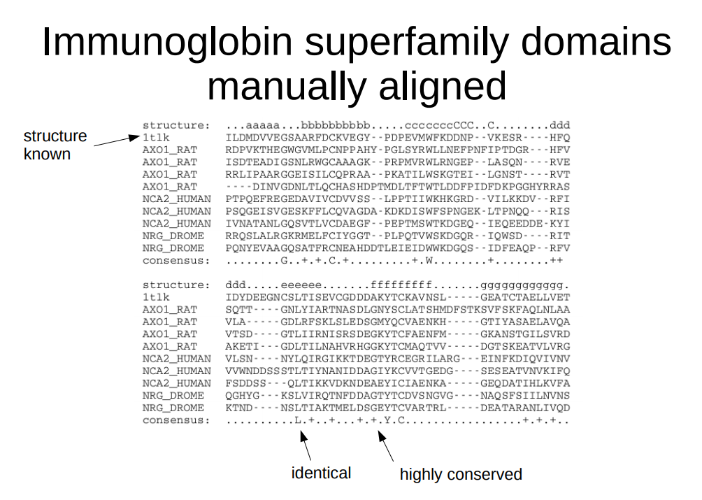

This example is of proteins which are similar structurally and functionally.
The consensus are telling us which letters are identical across all the listed proteins.
The letters displayed are letters which are the same across all the proteins.
The plusses are highly conserved so they're usually the same across the proteins but not always.
The dots are usually different.
We expect only a very mild overlap.

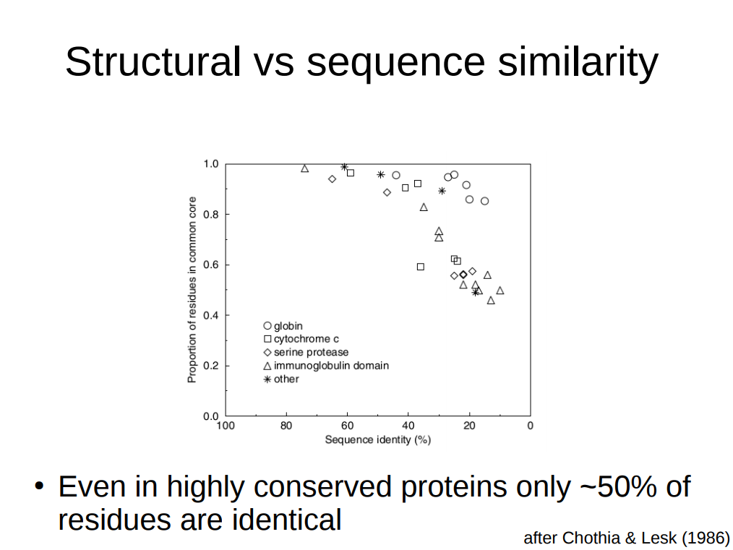

Common core – even if sequences are highly mutated, there can be sections which remain as a common core. But the similarities outside the common core can be like 20-30% usually. For DNA sequences, it can be higher because of degeneracy. The common core can be as small as 10-100 residues.

Sum of Pairs

In each position (like columns spanning down one letter in each protein), count the numbers of pairs. So CCC would make three pairs and ACC would be just one.
It's possible in priciple to introduce gap score and gap extension scores but typically this is not even used.

This score can be normalised up to the maximum score expressed as a fraction, but this doesn't change anything about its interpretation

The biggest flaw is that it assumes that the columns are independent of the other, but often times the relationship between subsequent nucleotides is quite crucial.

Also, the score is not a linear quantity so one mismatch can have a big difference on the score.

Slide 9
DP algorith, including NW, fails to do what already mentioned. 10 sqeuences with 1000 residues to look at gives you a memory complexity of 10^30 and a time complexity of 10^33 which is pretty bad.

Multiple sequence aligmnet
Introduce some heuristics – make some assumptions about data and hope outcome is still good enough
what MSA does is it tries to shrink enormous search space into something manageable
The first one that was done was based on the principle that if you have good pairwise alignments, then perhaps that pairise alinment might contribute to multiple sequence alignment, but if you not then not.
Constucts pairwise alignments between all possible pairs
then completes sum of squares scores
then threshold taken for score which are still included in msa and everything else discarded
the you end up with alignment matrix with most of elements empty

lower threshold, more complexity and slower
increase – it'll be faster but might miss correct alignment

progressive alignemnt
create alignment and iteraviley try to imprve
compute pairwise again
then compute scores eg normalised score to take into account sequences of different lengths
The scoring schemes can be used in different ways.
Could be fractions of maximum score or raw values.
These score in PA are used not to have a limited search space but to guide a set of second pairwise alignemtns going from the best to the worst match

put all scores into tree with highest first. That guide tree at each step perform pairwise alignment so you go from best to worst, then you end up with optimal alignemnt.

Clustalw

has an additional step
compute from existing alignemnts a profile. Some thing like a consensus sequence then try to make an alignment to the consensus
It removes a bit of noise when you're dealing with different alignments and you're not sure what order to put them in
then as you go through the tree the consensus gets more info and gets better then the poor alignemtns fo against that, not other poor alignemnts,

slide 11

what these methods are tested on are hand aligned protein families. This is kind of dangerous because you're comparing it with well put cases, but can't do it with dead genes.

Muscle

Start with unaligned sequences
compute score matric fgrom these
build guide tree
start first alignemnt
from that aligntmment do distance matrix (dont need to know this because other algorithms use something else, just usderstand pricnliople)
then another alignment
then in guide tree, nearby points closer together
so peresform alignemnts on parts of the tree successively like cutting the tree.
If you get a better score then iteratively keep cutting and try to improve alignemnts locally that most likely belong together anywaty
if cutting it fivbes you a worse score then discard and maybe try cutting again.

So basically first globlly rough alignmeny and then focus in and try to get more precise local alignements.

Good at identifieng conserved domains – common cores

Phylogenetics

When you have an alignment, you can look for similarities. This is a good indictaor of homology, Assume we have a set of homologous genes – of course they will have an amount of difference between them. The less the difference, then more closely related the specieis and the closer amont of time ago the ancestor lived.

Phylogenetics is important for Considering diseases models if you're studygin genes in animals I think because you want to make sure they're sumilar to the human gene/model.

Rooted and unrooted trees are the same thing in terms of distances and they're the same to a computer

rooted trees
looking at distances – indicator of relatedness
literally the distance ? Is 4 closer than 5 to 8?

use scoring aligments to make trees
like the blosom matrix

when we have a rough idea of when they diverged, it is interesting to look at nucleotide substitutions

not all substituions are equal – some are deadly and some don't matter at all. Selective pressures might determine rates of substitutions. Rate of substitutions is not always linear as a function of time.

Compute pairwaise distances between all possible pairs
eg differences between residues in pair
then you have a distance matrix between every possible apir
this matrix is symmetric
more sophistocated – amount of substitutions compared to random substittions with more sophistocated models (bio2)

matrix with numbers int hem which mean distance
then it's easy to cluster them and build a tree

use UPGMA to do this

glorious name for simple method!
Lookat matrix and all possible paris and yo uind the closest and put them together
then recompute a couple of distances
then do same thing again – put lowest pair closes together
and so on
and build a tree

distance formula

start off with all sequences unclustered and at the same level
d12 entries of distance matrix

all we have to do it look for closes pair which is 12 here. Then put them toether. Distance is 1 so have a distance of 1 between 1 and 2. travelling horizontally doesn't count, only vertically.

Recompute some distances and remove a few
remove 12
remove 13 because 1 is already connected with 2 and so on
now we have 3 and 4 left compute new distances with 5 to 3 and 5 to 4
rake the avergae of them because 2-1=1

pick the shortest one with is 3 and 4 and combine them

now compute distances between 5 and 6 – compute the avergaes again

but that isn't 56 …

then you can set a threshold to get groups like under 5 and under 6

idea of a constant substitution rate is called the molecular clock hypothesis. Introducing mutations at roughly constant rate. More time = more rotations. But this isn't entirely true.

In our bodies, we carry plenty of mutations especially as we grow older.

Most of it our skin because that divides all the time.

Original is if it took much longer for 1 than 2
but if we just look at plain substitutions, then get the upgma diagram

next mentioned for interesetd, not go into detail

neighbour joining
what you can do is for each edge, you can compute a distance where you take away the average edge length in tree. This can have certain advantages. Let's leave that out because it goes into too much detail.

UPGMA alg gives you a unique solution and it will not provide you any measue of uncertainty of how likely different solutions are.
We can use bootstapping where you rake your solution and your data and create some variability in data eg based on alignements for MSA
and then compute the tree
and look at tree paraeteres
and get some measure or cvaribaliilty
some links are robust and show up in any caser and some are more variable
then you can get an idea of certainty

come back in more detail in bio 2.

blast returns non homolgous proteins which will go in the tree as well

